**布局 Anatomy**

import React, { Component } from 'react';

import { Container, Header, Title, Content, Footer, FooterTab, Button, Left, Right, Body, Icon, Text } from 'native-base';

export default class AnatomyExample extends Component {

    render() {

        return (

            <Container>

                <Header>

                    <Left>

                        <Button transparent>

                            <Icon name='menu' />

                        </Button>

                    </Left>

                    <Body>

                        <Title>Header</Title>

                    </Body>

                    <Right />

                </Header>

                <Content>

                    <Text>

                        This is Content Section

                </Text>

                </Content>

                <Footer>

                    <FooterTab>

                        <Button full>

                            <Text>Footer</Text>

                        </Button>

                    </FooterTab>

                </Footer>

            </Container>

        );

    }

}

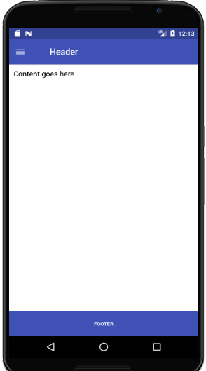

**手风琴 Accordion**

import React, { Component } from "react";

import { Container, Header, Content, Accordion } from "native-base";

const dataArray = [

    { title: "First Element", content: "Lorem ipsum dolor sit amet" },

    { title: "Second Element", content: "Lorem ipsum dolor sit amet" },

    { title: "Third Element", content: "Lorem ipsum dolor sit amet" }

];

export default class AccordionHeaderContentStyleExample extends Component {

    render() {

        return (

            <Container>

                <Header />

                <Content padder>

                    <Accordion

                        dataArray={dataArray}

                        headerStyle={{ backgroundColor: "#b7daf8" }}

                        contentStyle={{ backgroundColor: "#ddecf8" }}

                    />

                </Content>

            </Container>

        );

    }

}

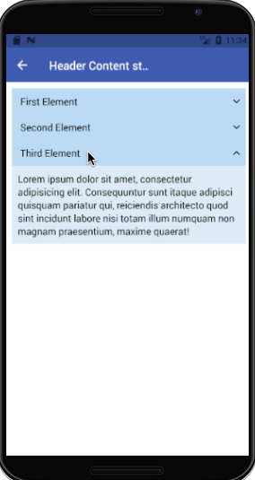

**行动表 ActionSheet （类似 Select）**

import React, { Component } from "react";

import { Container, Header, Button, Content, ActionSheet, Text } from "native-base";

var BUTTONS = [

    { text: "Option 0", icon: "american-football", iconColor: "#2c8ef4" },

    { text: "Option 1", icon: "analytics", iconColor: "#f42ced" },

    { text: "Option 2", icon: "aperture", iconColor: "#ea943b" },

    { text: "Delete", icon: "trash", iconColor: "#fa213b" },

    { text: "Cancel", icon: "close", iconColor: "#25de5b" }

];

var DESTRUCTIVE_INDEX = 3;

var CANCEL_INDEX = 4;

export default class ActionSheetIconExample extends Component {

    constructor(props) {

        super(props);

        this.state = {};

    }

    render() {

        return (

            <Container>

                <Header />

                <Content padder>

                    <Button

                        onPress={() =>

                            ActionSheet.show(

                                {

                                    options: BUTTONS,

                                    cancelButtonIndex: CANCEL_INDEX,

                                    destructiveButtonIndex: DESTRUCTIVE_INDEX,

                                    title: "Testing ActionSheet"

                                },

                                buttonIndex => {

                                    this.setState({ clicked: BUTTONS[buttonIndex] });

                                }

                            )}

                    >

                        <Text>Actionsheet</Text>

                    </Button>

                </Content>

            </Container>

        );

    }

}

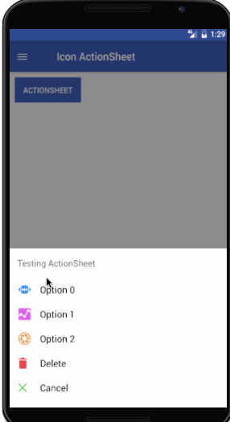

**徽章 Badge**

import React, { Component } from 'react';

import { Container, Header, Content, Badge, Text, Icon } from 'native-base';

export default class BadgeExample extends Component {

    render() {

        return (

            <Container>

                <Header />

                <Content>

                    <Badge>

                        <Text>2</Text>

                    </Badge>

                    <Badge primary>

                        <Text>2</Text>

                    </Badge>

                    <Badge success>

                        <Text>2</Text>

                    </Badge>

                    <Badge info>

                        <Text>2</Text>

                    </Badge>

                    <Badge warning>

                        <Text>2</Text>

                    </Badge>

                    <Badge danger>

                        <Text>2</Text>

                    </Badge>

                    <Badge primary>

                        <Icon name="star" style={{ fontSize: 15, color: "#fff", lineHeight: 20 }} />

                    </Badge>

                    <Badge style={{ backgroundColor: 'black' }}>

                        <Text style={{ color: 'white' }}>1866</Text>

                    </Badge>

                </Content>

            </Container>

        );

    }

}

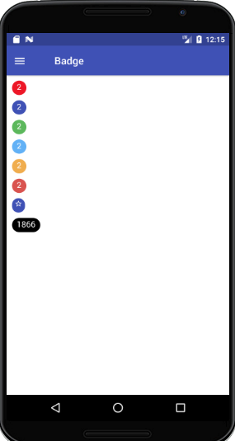

**按钮 Button**

import React, { Component } from 'react';

import { Container, Header, Content, Button, Text } from 'native-base';

export default class ButtonThemeExample extends Component {

    render() {

        return (

            <Container>

                <Header />

                <Content>

                    <Button light><Text> Light </Text></Button>

                    <Button primary><Text> Primary </Text></Button>

                    <Button success><Text> Success </Text></Button>

                    <Button info><Text> Info </Text></Button>

                    <Button warning><Text> Warning </Text></Button>

                    <Button danger><Text> Danger </Text></Button>

                    <Button dark><Text> Dark </Text></Button>

                </Content>

            </Container>

        );

    }

}

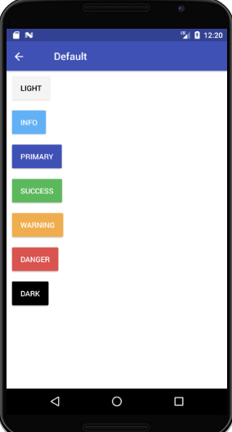

| **Property** | **Default** | **Option** | **Description** |
| --- | --- | --- | --- |
| active | - | boolean | State of button |
| transparent | true | boolean |  |
| bordered | - | - |  |
| rounded | - | - |  |
| block | - | - |  |
| full | - | - |  |
| disabled | true | boolean |  |
| small | - | - |  |
| large | - | - |  |
| iconRight | - | - |  |
| iconLeft | - | - | 同上 |
| light | - | boolean | Light white background color for button |
| primary | - | boolean | Blue background color for button |
| success | - | boolean | Green background color for button |
| info | - | boolean | Light blue background color for button |
| warning | - | boolean | Yellow background color for button |
| danger | - | boolean | Red background color for button |
| dark | - | boolean | Black background color for button |

**卡片 Card**

import React, { Component } from "react";

import { Container, Header, Content, Card, CardItem, Text, Body } from "native-base";

export default class CardItemBordered extends Component {

    render() {

        return (

            <Container>

                <Header />

                <Content padder>

                    <Card>

                        <CardItem header bordered>

                            <Text>NativeBase</Text>

                        </CardItem>

                        <CardItem bordered>

                            <Body>

                                <Text>

                                    NativeBase is a free and open source framework that enable

                                    developers to build

                                    high-quality mobile apps using React Native iOS and Android

                                    apps

                                    with a fusion of ES6.

                                </Text>

                            </Body>

                        </CardItem>

                        <CardItem footer bordered>

                            <Text>GeekyAnts</Text>

                        </CardItem>

                    </Card>

                </Content>

            </Container>

        );

    }

}

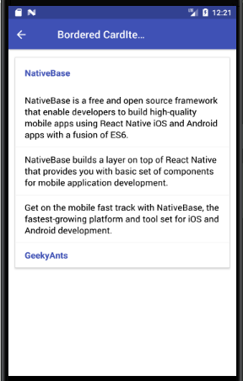

**卡片点击**

<CardItem header button onPress={() => alert("This is Card Header")}>

    <Text>NativeBase</Text>

</CardItem>

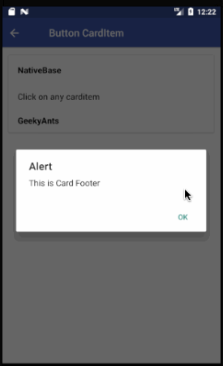

**卡片列表项**

import React, { Component } from 'react';

import { Container, Header, Content, Card, CardItem, Text, Icon, Right } from 'native-base';

export default class CardListExample extends Component {

    render() {

        return (

            <Container>

                <Header />

                <Content>

                    <Card>

                        <CardItem>

                            <Icon active name="logo-googleplus" />

                            <Text>Google Plus</Text>

                            <Right>

                                <Icon name="arrow-forward" />

                            </Right>

                        </CardItem>

                    </Card>

                </Content>

            </Container>

        );

    }

}

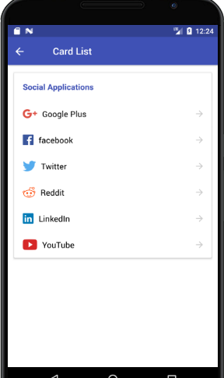

**图片卡片**

import React, { Component } from 'react';

import { Image } from 'react-native';

import { Container, Header, Content, Card, CardItem, Thumbnail, Text, Button, Icon, Left, Body, Right } from 'native-base';

export default class CardImageExample extends Component {

    render() {

        return (

            <Container>

                <Header />

                <Content>

                    <Card>

                        <CardItem>

                            <Left>

                                <Thumbnail source={{ uri: 'Image URL' }} />

                                <Body>

                                    <Text>NativeBase</Text>

                                    <Text note>GeekyAnts</Text>

                                </Body>

                            </Left>

                        </CardItem>

                        <CardItem cardBody>

                            <Image source={{ uri: 'Image URL' }} style={{ height: 200, width: null, flex: 1 }} />

                        </CardItem>

                        <CardItem>

                            <Left>

                                <Button transparent>

                                    <Icon active name="thumbs-up" />

                                    <Text>12 Likes</Text>

                                </Button>

                            </Left>

                            <Body>

                                <Button transparent>

                                    <Icon active name="chatbubbles" />

                                    <Text>4 Comments</Text>

                                </Button>

                            </Body>

                            <Right>

                                <Text>11h ago</Text>

                            </Right>

                        </CardItem>

                    </Card>

                </Content>

            </Container>

        );

    }

}

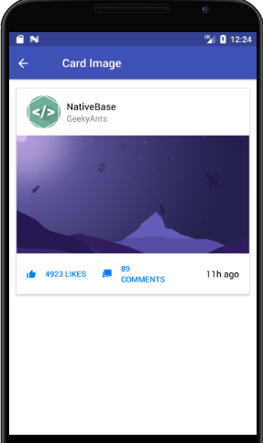

**复选框 Check Box**

import React, { Component } from 'react';

import { Container, Header, Content, ListItem, CheckBox, Text, Body } from 'native-base';

export default class CheckBoxExample extends Component {

    render() {

        return (

            <Container>

                <Header />

                <Content>

                    <ListItem>

                        <CheckBox checked={true} />

                        <Body>

                            <Text>Daily Stand Up</Text>

                        </Body>

                    </ListItem>

                    <ListItem>

                        <CheckBox checked={false} />

                        <Body>

                            <Text>Discussion with Client</Text>

                        </Body>

                    </ListItem>

                    <ListItem>

                        <CheckBox checked={false} color="green" />

                        <Body>

                            <Text>Finish list Screen</Text>

                        </Body>

                    </ListItem>

                </Content>

            </Container>

        );

    }

}



**日期选择器 Date Picker**

import React, { Component } from 'react';

import { Container, Header, Content, DatePicker, Text } from 'native-base';

export default class DatePickerExample extends Component {

    constructor(props) {

        super(props);

        this.state = { chosenDate: new Date() };

        this.setDate = this.setDate.bind(this);

    }

    setDate(newDate) {

        this.setState({ chosenDate: newDate });

    }

    render() {

        return (

            <Container>

                <Header />

                <Content>

                    <DatePicker

                        defaultDate={new Date(2018, 4, 4)}

                        minimumDate={new Date(2018, 1, 1)}

                        maximumDate={new Date(2018, 12, 31)}

                        locale={"en"}

                        timeZoneOffsetInMinutes={undefined}

                        modalTransparent={false}

                        animationType={"fade"}

                        androidMode={"default"}

                        placeHolderText="Select date"

                        textStyle={{ color: "green" }}

                        placeHolderTextStyle={{ color: "#d3d3d3" }}

                        onDateChange={this.setDate}

                        disabled={false}

                    />

                    <Text>

                        Date: {this.state.chosenDate.toString().substr(4, 12)}

                    </Text>

                </Content>

            </Container>

        );

    }

}



**左滑右滑下一个 Deck Swiper**

import React, { Component } from 'react';

import { Image } from 'react-native';

import { Container, Header, View, DeckSwiper, Card, CardItem, Thumbnail, Text, Left, Body, Icon } from 'native-base';

const cards = [

    {

        text: 'Card One',

        name: 'One',

        image: require('./img/swiper-1.png'),

    },

  .  .  .

];

export default class DeckSwiperExample extends Component {

    render() {

        return (

            <Container>

                <Header />

                <View>

                    <DeckSwiper

                        dataSource={cards}

                        renderItem={item =>

                            <Card style={{ elevation: 3 }}>

                                <CardItem>

                                    <Left>

                                        <Thumbnail source={item.image} />

                                        <Body>

                                            <Text>{item.text}</Text>

                                            <Text note>NativeBase</Text>

                                        </Body>

                                    </Left>

                                </CardItem>

                                <CardItem cardBody>

                                    <Image style={{ height: 300, flex: 1 }} source={item.image} />

                                </CardItem>

                                <CardItem>

                                    <Icon name="heart" style={{ color: '#ED4A6A' }} />

                                    <Text>{item.name}</Text>

                                </CardItem>

                            </Card>

                        }

                    />

                </View>

            </Container>

        );

    }

}

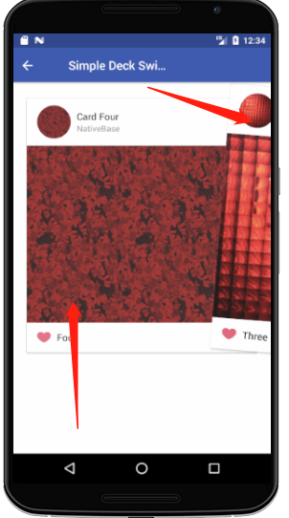

**按钮弹出 FABs**

import React, { Component } from 'react';

import { Container, Header, View, Button, Icon, Fab } from 'native-base';

export default class FABExample extends Component {

    constructor(props) {

        super(props)

        this.state = {

            active: false

        };

    }

    render() {

        return (

            <Container>

                <Header />

                <View style={{ flex: 1 }}>

                    <Fab

                        active={this.state.active}

                        direction="up"

                        containerStyle={{}}

                        style={{ backgroundColor: '#5067FF' }}

                        position="bottomRight"

                        onPress={() => this.setState({ active: !this.state.active })}>

                        <Icon name="share" />

                        <Button style={{ backgroundColor: '#34A34F' }}>

                            <Icon name="logo-whatsapp" />

                        </Button>

                        <Button style={{ backgroundColor: '#3B5998' }}>

                            <Icon name="logo-facebook" />

                        </Button>

                        <Button disabled style={{ backgroundColor: '#DD5144' }}>

                            <Icon name="mail" />

                        </Button>

                    </Fab>

                </View>

            </Container>

        );

    }

}

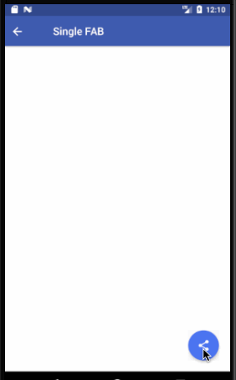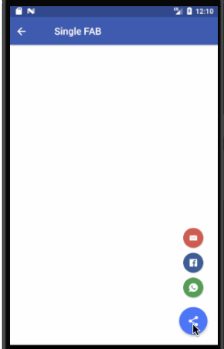

**指定不同位置不同方向**

<Fab direction="left" position="topRight">

**底部标签 Footer Tabs**

import React, { Component } from 'react';

import { Container, Header, Content, Footer, FooterTab, Button, Icon } from 'native-base';

export default class FooterTabsIconExample extends Component {

    render() {

        return (

            <Container>

                <Header />

                <Content />

                <Footer>

                    <FooterTab>

                        <Button>

                            <Icon name="apps" />

                        </Button>

                        <Button>

                            <Icon name="camera" />

                        </Button>

                        <Button active>

                            <Icon active name="navigate" />

                        </Button>

                        <Button>

                            <Icon name="person" />

                        </Button>

                    </FooterTab>

                </Footer>

            </Container>

        );

    }

}

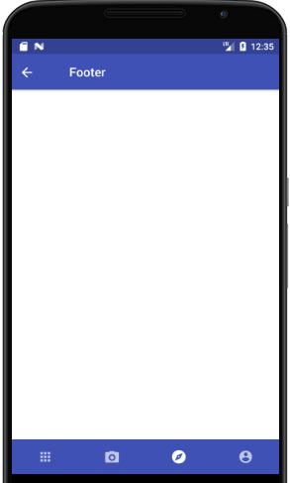

**表单 Form**

import React, { Component } from 'react';

import { Container, Header, Content, Form, Item, Input, Label } from 'native-base';

export default class FloatingLabelExample extends Component {

    render() {

        return (

            <Container>

                <Header />

                <Content>

                    <Form>

                        <Item floatingLabel>

                            <Label>Username</Label>

                            <Input />

                        </Item>

                        <Item floatingLabel last>

                            <Label>Password</Label>

                            <Input />

                        </Item>

                    </Form>

                </Content>

            </Container>

        );

    }

}



**Select 框 Picker Input**

import React, { Component } from 'react';

import { Container, Header, Content, Form, Item, Picker } from 'native-base';

export default class PickerInputExample extends Component {

    constructor(props) {

        super(props);

        this.state = {

            selected2: undefined

        };

    }

    onValueChange2(value: string) {

        this.setState({

            selected2: value

        });

    }

    render() {

        return (

            <Container>

                <Header />

                <Content>

                    <Form>

                        <Item picker>

                            <Picker

                                mode="dropdown"

                                iosIcon={<Icon name="arrow-down" />}

                                style={{ width: undefined }}

                                placeholder="Select your SIM"

                                placeholderStyle={{ color: "#bfc6ea" }}

                                placeholderIconColor="#007aff"

                                selectedValue={this.state.selected2}

                                onValueChange={this.onValueChange2.bind(this)}

                            >

                                <Picker.Item label="Wallet" value="key0" />

                                <Picker.Item label="ATM Card" value="key1" />

                                <Picker.Item label="Debit Card" value="key2" />

                                <Picker.Item label="Credit Card" value="key3" />

                                <Picker.Item label="Net Banking" value="key4" />

                            </Picker>

                        </Item>

                    </Form>

                </Content>

            </Container>

        );

    }

}

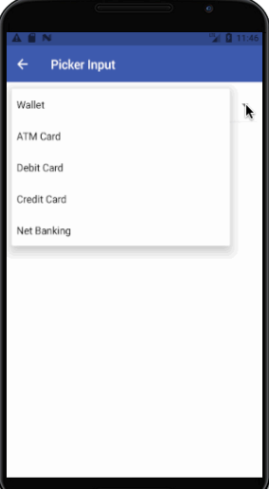

**常规文本框**

import React, { Component } from 'react';

import { Container, Header, Content, Input, Item } from 'native-base';

export default class RegularTextboxExample extends Component {

    render() {

        return (

            <Container>

                <Header />

                <Content>

                    <Item regular>

                        <Input placeholder='Regular Textbox' />

                    </Item>

                </Content>

            </Container>

        );

    }

}

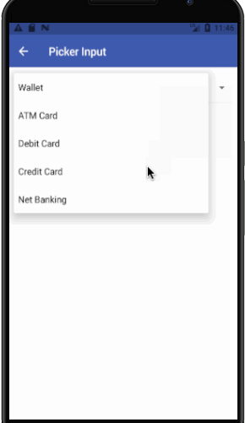

**圆角文本框**

import React, { Component } from 'react';

import { Container, Header, Content, Item, Input } from 'native-base';

export default class RoundedTextboxExample extends Component {

    render() {

        return (

            <Container>

                <Header />

                <Content>

                    <Item rounded>

                        <Input placeholder='Rounded Textbox' />

                    </Item>

                </Content>

            </Container>

        );

    }

}

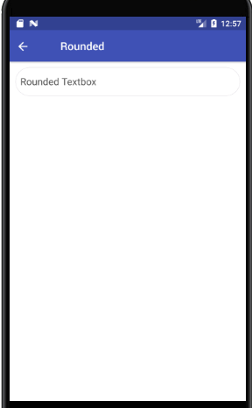

**有图标的文本框**

<Item>

    <Icon active name='home' />

    <Input placeholder='Icon Textbox' />

</Item>

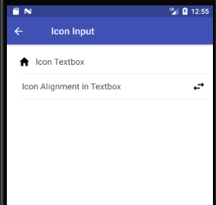

**不同样式的文本框（成功，错误等）**

<Item success>

    <Input placeholder='Textbox with Success Input' />

    <Icon name='checkmark-circle' />

</Item>



**Textarea**

import React, { Component } from "react";

import { Container, Header, Content, Textarea, Form } from "native-base";

export default class TextArea extends Component {

    render() {

        return (

            <Container>

                <Header />

                <Content padder>

                    <Form>

                        <Textarea rowSpan={5} bordered placeholder="Textarea" />

                    </Form>

                </Content>

            </Container>

        );

    }

}

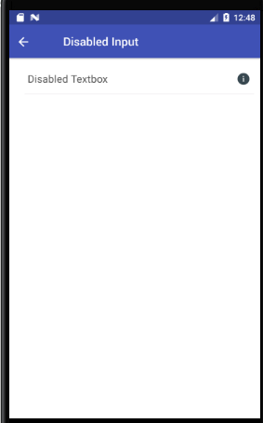

**头部 Header**

import React, { Component } from 'react';

import { Container, Header, Left, Body, Right, Button, Icon, Title } from 'native-base';

export default class HeaderIconExample extends Component {

    render() {

        return (

            <Container>

                <Header>

                    <Left>

                        <Button transparent>

                            <Icon name='arrow-back' />

                        </Button>

                    </Left>

                    <Body>

                        <Title>Header</Title>

                    </Body>

                    <Right>

                        <Button transparent>

                            <Icon name='menu' />

                        </Button>

                    </Right>

                </Header>

            </Container>

        );

    }

}

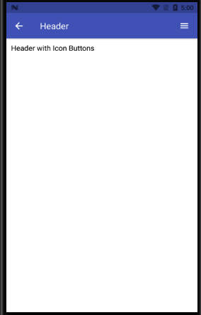

| **Property** | **Default** | **Option** | **Description** |
| --- | --- | --- | --- |
| Left | - | - | Components render to the left in Header |
| Body | - | - | Components render at the center of Header |
| Right | - | - | Components render to the right in Header |
| iosBarStyle | - | light-content, dark-content, default | Set iOS barStyle |
| androidStatusBarColor | - | - | Set background color for status bar in android |
| noShadow | - | boolean | Removes elevation from android |
| searchBar | - | boolean | Add searchbar to header or not |
| rounded | - | boolean | Make header searchbar rounded |
| hasSubtitle | - | boolean | Add subtitle to header |
| hasSegment | - | boolean | Add segments to header |
| hasTabs | - | boolean | Add tabs to header |
| hasText | - | boolean | This is button prop. Adds necessary padding when Text button defined in Left / Right of Header (iOS) |
| noLeft | - | boolean | Eliminates Left component and moves Title towards left (Android) |
| span | - | boolean | Doubles the header size |
| transparent | - | boolean | removes border of Header,shadow from iOS Header and elevation from Android Header. |

**图标Icon**

图标使用React Native Vector Icons图标

import React, { Component } from 'react';

import { Container, Header, Content, Icon } from 'native-base';

export default class IconExample extends Component {

    render() {

        return (

            <Container>

                <Header />

                <Content>

                    <Icon name='home' />

                    <Icon ios='ios-menu' android="md-menu" style={{ fontSize: 20, color: 'red' }} />

                    <Icon type="FontAwesome" name="home" />

                </Content>

            </Container>

        );

    }

}

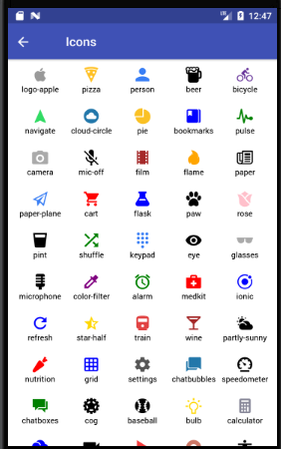

**布局 Layout**

import React, { Component } from 'react';

import { Container, Header } from 'native-base';

import { Col, Row, Grid } from 'react-native-easy-grid';

export default class LayoutExample extends Component {

    render() {

        return (

            <Container>

                <Header />

                <Grid>

                    <Col style={{ backgroundColor: '#635DB7', height: 200 }}></Col>

                    <Col style={{ backgroundColor: '#00CE9F', height: 200 }}></Col>

                </Grid>

            </Container>

        );

    }

}

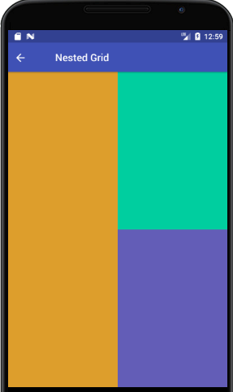

**列表 List**

import React, { Component } from 'react';

import { Container, Header, Content, List, ListItem, Text } from 'native-base';

export default class ListExample extends Component {

    render() {

        return (

            <Container>

                <Header />

                <Content>

                    <List>

                        <ListItem>

                            <Text>Simon Mignolet</Text>

                        </ListItem>

                        <ListItem>

                            <Text>Nathaniel Clyne</Text>

                        </ListItem>

                        <ListItem>

                            <Text>Dejan Lovren</Text>

                        </ListItem>

                    </List>

                </Content>

            </Container>

        );

    }

}

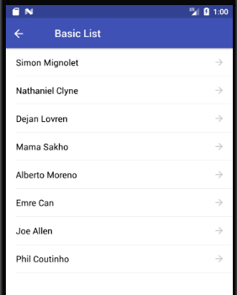

**分组列表**

import React, { Component } from 'react';

import { Container, Header, Content, List, ListItem, Text } from 'native-base';

export default class ListDividerExample extends Component {

    render() {

        return (

            <Container>

                <Header />

                <Content>

                    <List>

                        <ListItem itemDivider>

                            <Text>A</Text>

                        </ListItem>

                        <ListItem>

                            <Text>Aaron Bennet</Text>

                        </ListItem>

                        <ListItem>

                            <Text>Ali Connors</Text>

                        </ListItem>

                        <ListItem itemDivider>

                            <Text>B</Text>

                        </ListItem>

                        <ListItem>

                            <Text>Bradley Horowitz</Text>

                        </ListItem>

                    </List>

                </Content>

            </Container>

        );

    }

}

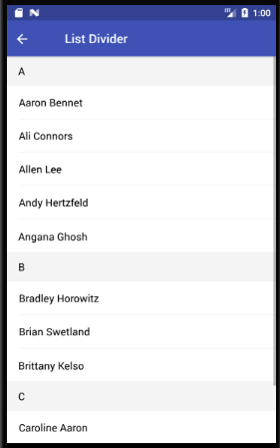

**选中样式**

<ListItem selected>

    <Left>

        <Text>Simon Mignolet</Text>

    </Left>

    <Right>

        <Icon name="arrow-forward" />

    </Right>

</ListItem>

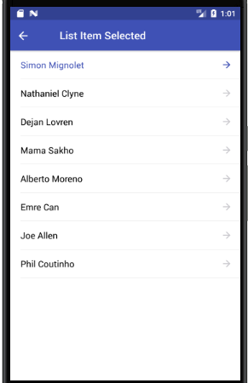

**选择框 Picker**

import React, { Component } from "react";

import { Container, Header, Content, Picker, Form } from "native-base";

export default class PickerExample extends Component {

    constructor(props) {

        super(props);

        this.state = {

            selected: "key1"

        };

    }

    onValueChange(value: string) {

        this.setState({

            selected: value

        });

    }

    render() {

        return (

            <Container>

                <Header />

                <Content>

                    <Form>

                        <Picker

                            note

                            mode="dropdown"

                            style={{ width: 120 }}

                            selectedValue={this.state.selected}

                            onValueChange={this.onValueChange.bind(this)}

                        >

                            <Picker.Item label="Wallet" value="key0" />

                            <Picker.Item label="ATM Card" value="key1" />

                            <Picker.Item label="Debit Card" value="key2" />

                            <Picker.Item label="Credit Card" value="key3" />

                            <Picker.Item label="Net Banking" value="key4" />

                        </Picker>

                    </Form>

                </Content>

            </Container>

        );

    }

}

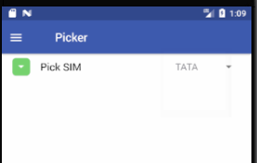

**单选框Radio Button**

import React, { Component } from 'react';

import { Container, Header, Content, ListItem, Text, Radio, Right, Left } from 'native-base';

export default class RadioButtonExample extends Component {

    render() {

        return (

            <Container>

                <Header />

                <Content>

                    <ListItem>

                        <Left>

                            <Text>Daily Stand Up</Text>

                        </Left>

                        <Right>

                            <Radio selected={false} />

                        </Right>

                    </ListItem>

                    <ListItem>

                        <Left>

                            <Text>Discussion with Client</Text>

                        </Left>

                        <Right>

                            <Radio selected={true} />

                        </Right>

                    </ListItem>

                </Content>

            </Container>

        );

    }

}



**搜索框 Search Bar**

import React, { Component } from 'react';

import { Container, Header, Item, Input, Icon, Button, Text } from 'native-base';

export default class SearchBarExample extends Component {

    render() {

        return (

            <Container>

                <Header searchBar rounded>

                    <Item>

                        <Icon name="ios-search" />

                        <Input placeholder="Search" />

                        <Icon name="ios-people" />

                    </Item>

                    <Button transparent>

                        <Text>Search</Text>

                    </Button>

                </Header>

            </Container>

        );

    }

}

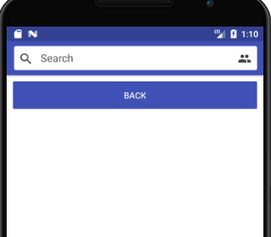

**分割 Segment**

import React, { Component } from 'react';

import { Container, Header, Left, Body, Right, Button, Icon, Segment, Content, Text } from 'native-base';

export default class SegmentExample extends Component {

    render() {

        return (

            <Container>

                <Header hasSegment>

                    <Left>

                        <Button transparent>

                            <Icon name="arrow-back" />

                        </Button>

                    </Left>

                    <Body>

                        <Segment>

                            <Button first><Text>Puppies</Text></Button>

                            <Button last active><Text>Cubs</Text></Button>

                        </Segment>

                    </Body>

                    <Right>

                        <Button transparent>

                            <Icon name="search" />

                        </Button>

                    </Right>

                </Header>

                <Content padder>

                    <Text>Awesome segment</Text>

                </Content>

            </Container>

        );

    }

}

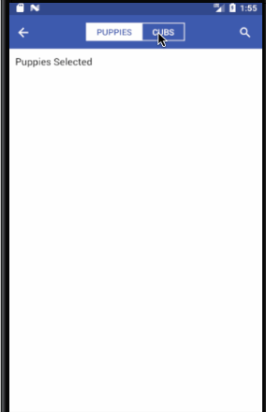

**加载中 Spinner**

import React, { Component } from 'react';

import { Container, Header, Content, Spinner } from 'native-base';

export default class SpinnerExample extends Component {

    render() {

        return (

            <Container>

                <Header />

                <Content>

                    <Spinner />

                    <Spinner color='red' />

                    <Spinner color='green' />

                    <Spinner color='blue' />

                </Content>

            </Container>

        );

    }

}

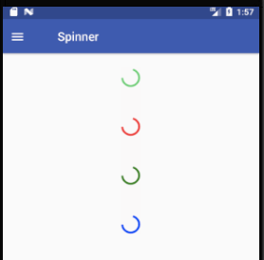

**标签**

import Tab1 from './tabOne';

. . .

import Tab5 from './tabFive';

export default class TabsScrollableExample extends Component {

    render() {

        return (

            <Container>

                <Header hasTabs />

                <Tabs renderTabBar={() => <ScrollableTab />}>

                    <Tab heading="Tab1">

                        <Tab1 />

                    </Tab>

                    <Tab heading="Tab2">

                        <Tab2 />

                    </Tab>

                    <Tab heading="Tab3">

                        <Tab3 />

                    </Tab>

                    <Tab heading="Tab4">

                        <Tab4 />

                    </Tab>

                    <Tab heading="Tab5">

                        <Tab5 />

                    </Tab>

                </Tabs>

            </Container>

        );

    }

}

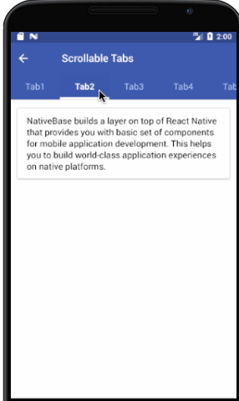

**Thumbnail缩图**

缩图可以展示各种尺寸和形状的图片

import React, { Component } from 'react';

import { Container, Header, Content, Thumbnail, Text } from 'native-base';

export default class ThumbnailExample extends Component {

    render() {

        const uri = "https://facebook.github.io/react-native/docs/assets/favicon.png";

        return (

            <Container>

                <Header />

                <Content>

                    <Text>Square Thumbnail</Text>

                    <Thumbnail square small source={{ uri: uri }} />

                    <Thumbnail square source={{ uri: uri }} />

                    <Thumbnail square large source={{ uri: uri }} />

                    <Text>Circular Thumbnail</Text>

                    <Thumbnail small source={{ uri: uri }} />

                    <Thumbnail source={{ uri: uri }} />

                    <Thumbnail large source={{ uri: uri }} />

                </Content>

            </Container>

        );

    }

}

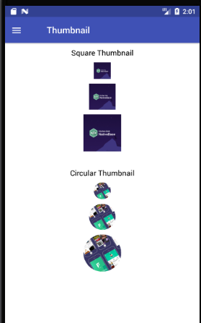

**吐司Toast**

NativeBase Toast可用于显示快速警告或错误消息

要想其正常工作，你需要使用Root包括你的应用

import { Root } from "native-base";

export default () =>

  <Root>

    ...

  </Root>;

代码

import React, { Component } from 'react';

import { Container, Header, Content, Toast, Button, Text } from 'native-base';

export default class ToastExample extends Component {

    render() {

        return (

            <Container>

                <Header />

                <Content padder>

                    <Button onPress={() => Toast.show({

                        text: 'Wrong password!',

                        buttonText: 'Okay'

                    })}>

                        <Text>Toast</Text>

                    </Button>

                </Content>

            </Container>

        );

    }

}

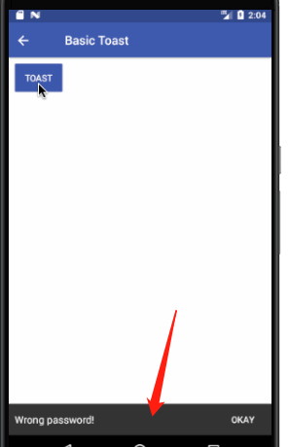

**文本组件 Typography**

import React, { Component } from 'react';

import { Container, Header, Content, H1, H2, H3, Text } from 'native-base';

export default class TypographyExample extends Component {

    render() {

        return (

            <Container>

                <Header />

                <Content>

                    <H1>Header One</H1>

                    <H2>Header Two</H2>

                    <H3>Header Three</H3>

                    <Text>Default</Text>

                </Content>

            </Container>

        );

    }

}

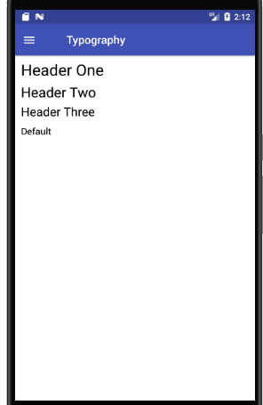

**抽屉 Drawer**

import React, { Component } from 'react';

import { Drawer } from 'native-base';

export default class DrawerExample extends Component {

    closeDrawer = () => {

        this.drawer._root.close()

    }

    openDrawer = () => {

        this.drawer._root.open()

};

    render() {

        // 注 Drawer 的样式是 flex:1, 因此其父组件必须有明确高度

        return (

            <Drawer

                ref={(ref) => { this.drawer = ref; }}

                content={<Text>aaaa</Text>}

                onClose={() => this.closeDrawer()}

            >

                <View>

                <Text>aaabbba</Text>

                </View>

            </Drawer>);

    }

}

